A

PROJECT REPORT

ON

**MonetizeSkill**

SUBMITTED BY -

**Ankit Seth**

**Seat No:**

UNDER THE GUIDANCE OF

**Ms. Madhavi Mahajan**

SAVITRIBAI PHULE PUNE UNIVERSITY (SPPU)

MASTER OF COMPUTER APPLICATIONS



DR. D. Y. PATIL UNITECH SOCIETY’S

DR. D. Y. PATIL INSTITUTE OF MANAGEMENT AND RESEARCH, PIMPRI, PUNE-18

2023-2024

**Dr. D. Y. Patil Unitech Society’s**

**Dr. D.Y. PATIL INSTITUTE OF MANAGEMENT & RESEARCH  
Sant Tukaram Nagar, Pimpri, Pune-411018**

**Recognized by the Savitribai Phule Pune University (SPPU-IMMP014220) AISHE CODE C-42109**

|  |  |  |
| --- | --- | --- |
| Recipient of the "Best College Award” of Savitribai Phule Pune University | Accredited by NAAC with "A++ Grade” (CGPA 3.52) | MBA & MCA Programme Accredited by NBA |
|  |  |  |

**CERTIFICATE**

This is to certify that **Mr.Ankit Seth** has successfully completed the project on **MonetizeSkill** as a partial fulfilment of his **Master of Computer Applications (MCA)** under the curriculum of **Savitribai Phule Pune University, Pune**  for the academic year 2023-24

Ms.Madhavi Majahan Dr. Shikha Dubey Dr. Meghana Bhilare

**Project Guide H.O.D. MCA Director**

Signature Signature

Name Name

**Internal Examiner**  **External Examiner**

Date : Date :

**Acknowledgement**

The success and final outcome of this project required a lot of guidance and assistance from many people and we are extremely privileged to have got this all along the completion of our project. All that we have done is only due to such supervision and assistance and we would not forget to thank them.

We sincerely thank to the Director **Dr. Meghana Bhilare**, Associate Director **Dr. Vishal Wadajkar**, and HOD **Dr. Shikha Dubey** and to my project guide **Miss.Madhavi Mahajan**, for providing us an opportunity to do the project work and give us all support and guidance which made us completes the project duty. We are extremely thankful to them for providing such a nice support and guidance, although they had busy schedule managing the corporate affairs.

We owe a deep gratitude to our project guides for taking keep interest on our project work and guiding us all along, till the completion of our project work by providing all the necessary information for developing good system.

We are thankful to and fortunate enough to get constant encouragement, support and guidance from all teaching staff which helped us in successfully completing our project work. Also, we would like to extend our sincere esteems to all staff in laboratory for their timely support.

**Index**

|  |  |  |
| --- | --- | --- |
| **Sr. No** | **Documentation Content** | **Page No** |
| **I** | **Introduction** | |
| 1 | Motivation | 4 |
| 2 | Problem Statement | 5 |
| 3 | Purpose / Objective and Goals | 5 ,6 |
| 4 | Literature Survey | 6 |
| **II** | **System analysis** | |
| 1 | Existing Systems | 7 |
| 2 | Scope and Limitations of Existing Systems | 7 |
| 3 | Project Perspective , Features | 7 |
| 4 | Requirement Analysis -  Functional requirements, Performance requirements,  Security requirements etc | 8 ,9 |
| **III** | **System Design** | |
| 1 | Class Diagram | 10 |
| 2 | Use Case ,Activity Diagram , Sequence Diagram , Deployment Diagram | 11-14 |
|  |  |  |
| **IV** | **Implementation details** | |
| 1 | Software / Hardware Specifications | 15 |
| **V** | **Outputs and Reports Testing** | |
| 1 | Screenshot and Report | 15-22 |

**Motivation**

We own our sincere gratitude to all those people who have given us their constant support and encouragement without which our project report would not have reached this stage.

We would like to express our thanks to Prof Dipika mam for her advice and encouragement. She has been a pillar of strength right through the project till the preparation of this report and helped by boosting morale, so we could surmount the difficulties that came across during completion of this project.

We would like to express our gratitude to XDr.A.P.Rajput and incharge principal Dr.A.D.Nandurker, Principal, K.K.Wagh Arts, commerce, science and Computer Science College and Prof.Vijayshri Bava, Head of Computer Application department for the support and the infrastructure they have provided, so that we could successfully complete the project on time.

Last but not the least, we would like to express our sincere thanks to all staff members and our friends for their help and cooperation in all phases of the project.

1. Ankit Kumar Seth

**Problem Statement**

* If you were a college student you had definitely imagined if you could have earned at least some money, and buy yourself a fancy watch or something.
* Believe if you have a skill of photography, coding, graphic designing or any other skill that has some impact on any field of study and help you earn some money, wouldn’t that be great.
* Since the past 10 years internet has become an integral part of your life and humans have perfectly used it in making our lives simple.
* The important aspect is you wanted to make money by either learning a skill or by applying the skill you had.
* Arriving to present situation due to the pandemic a lot companies are anticipated to hire freelancers.

**Purpose**

* The purpose of this project is to enable all the student or the one’s how want to earn money but not by doing a 9 to5 job rather using their skill to do freelancing.
* This website allows companies approach the one who desire to do freelancing.

**Literature Survey**

* Reference from fiver.

**Existing System**

* In the existing system that is in the past 10 years there was no proper platform for freelancers and companies to make a conversation.
* The person how want job had to transit.

**Limitations of Existing Systems**

* Difficult to find freelancing jobs.
* Waste of resources of companies in hiring individuals by going to various places for hiring.

**Scope**

Future improvements

* This website will give recommendation of profiles related to your field of study.
* Website will be improved to handle a large set to users.
* Security refinement will be made.
* Later users may also be able to add posts in their profile.

**Project Perspective**

* This website can be used by companies hiring individuals.
* This website can be used my any person.

**Features**

* It will save energy and time.
* Easy to register.
* Easy to find oportunity for job.
* User can upload the testimony for their pervious work as photos of links.
* User can search the type of person they want to hire.

**Performence Requirements**

In order to maintain the acceptable speed at maximum number of uploads allowed from a particular customer will be any number of users can access the system at any time. Also connections to the server will be based on the criteria of attributes of the user like his location, and server will be working whole 24*7 times.

**Functional Requirements**

The problem under study is being divided into several modules/functions discussed below to understand the approach to the solution in the broader way:

* **User Registration**
* **Welcome and Login Page**
* **About page(fill personal details,educational details,upload previous work)**
* **Contact details**
* **Search for jobs**

**Non-functional Rquirements :**

**Security :**  The system must automatically log out all customers after a period inactivity. The system’s back-end servers shall only be accessible to the authenticated administrators. Sensitive data will be encrypted before being sent over insecure connections like the internet.

**Reliability :** The Reliability of the overall at all times, meaning the user can access it using a web browser, only restricted by the down time of the server on which the system runs. In case of a hardware failure or databse corruption, a replacement page will be shown. Also in case of a hardware failure or databse corruption, backups of the databse should be retrived from the server and saved by the administrator.

**Maintainability :** A commercial database is used for maintaining the databse and the application server takes care of the site. In case of a failure, a re-initialization of the program will be done. Also the software design is being done with modularity in mind so that maintainability can be done efficiently.

**Portability :**  The application in HTML and scripted language based. So the end-user part is fully portable and any system using web browser should be able to use the features of the system, including any hardware platform that is available or will be available in the future. And end-user is use the system or any OS; either it is Windows or Linux. The system shall run on PC, Laptops and PDA etc.

**Class Diaram**

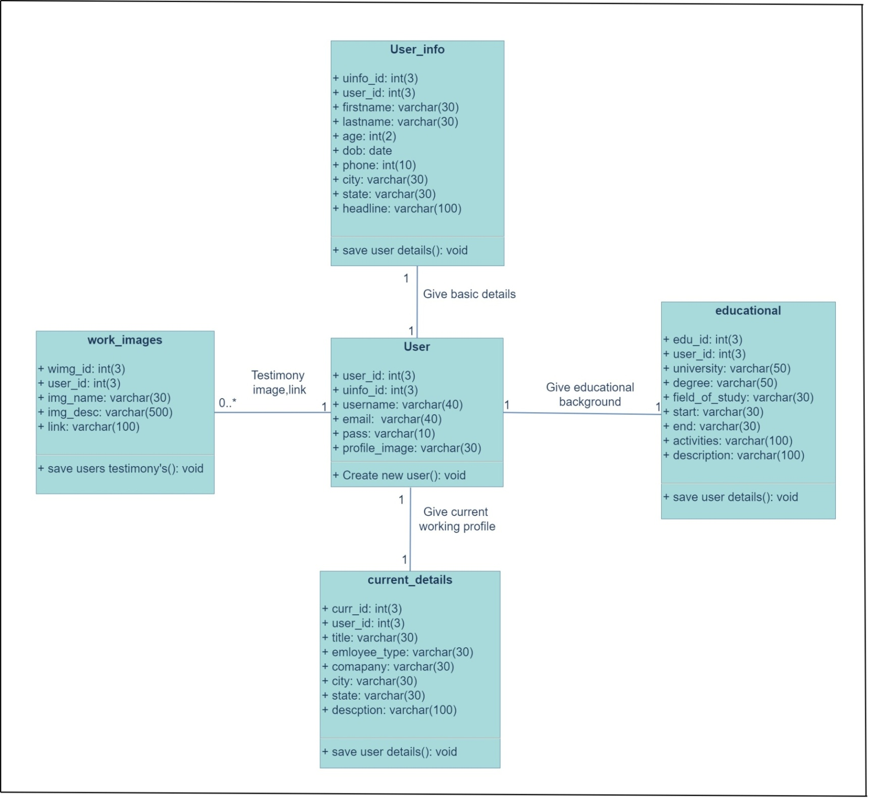

**Use case Diagram**

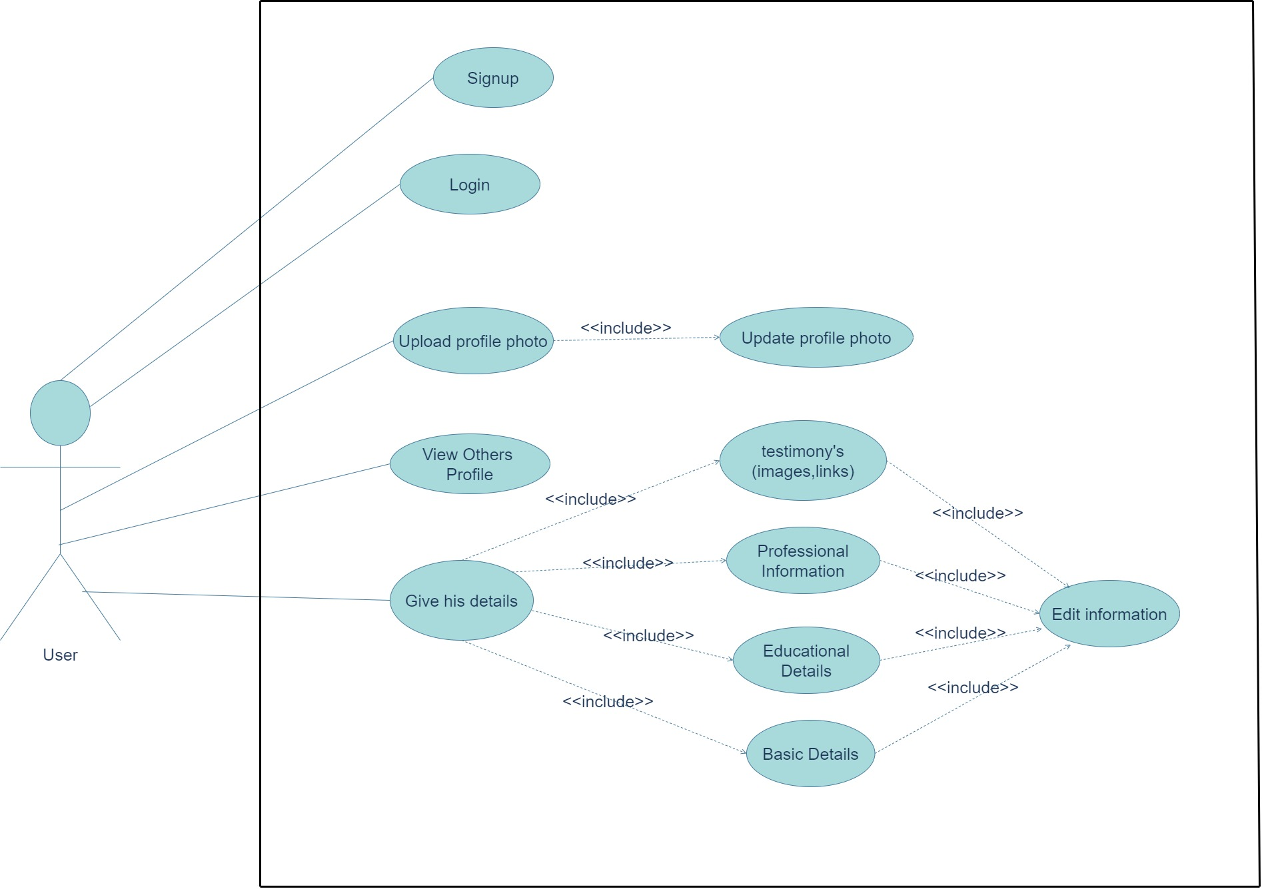

**Sequence Diagram**

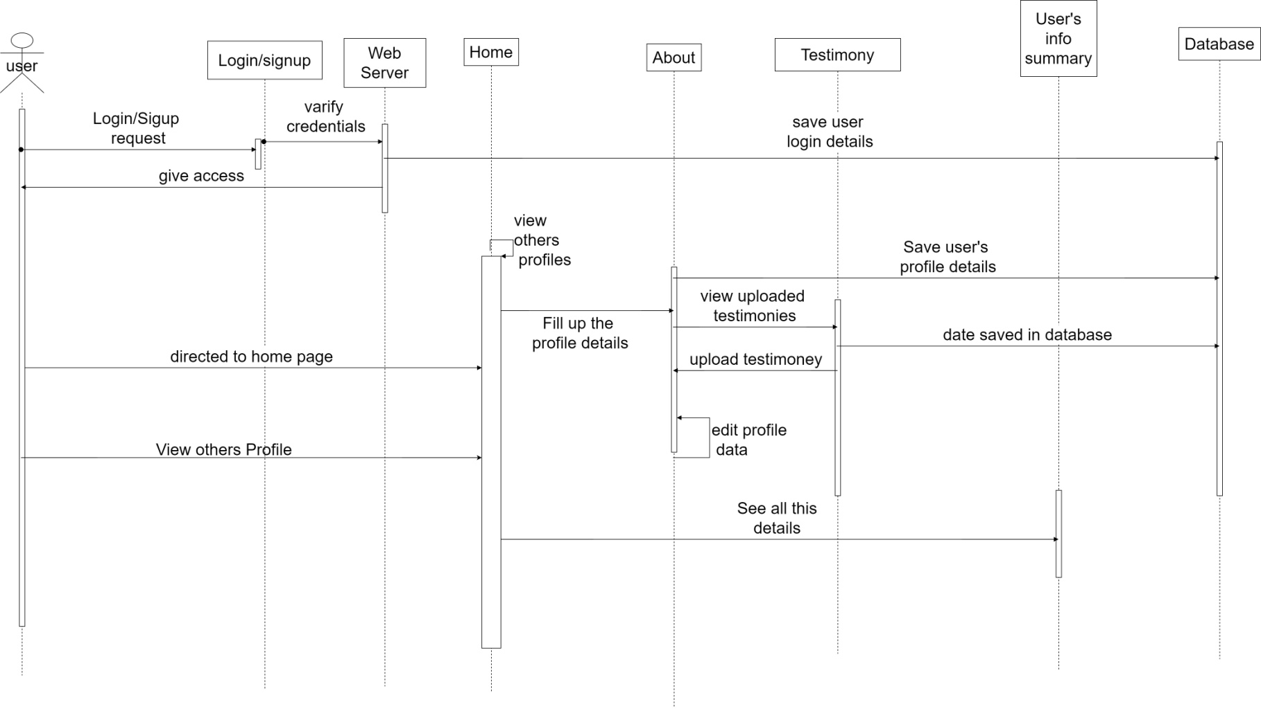

**Activity Diagram**

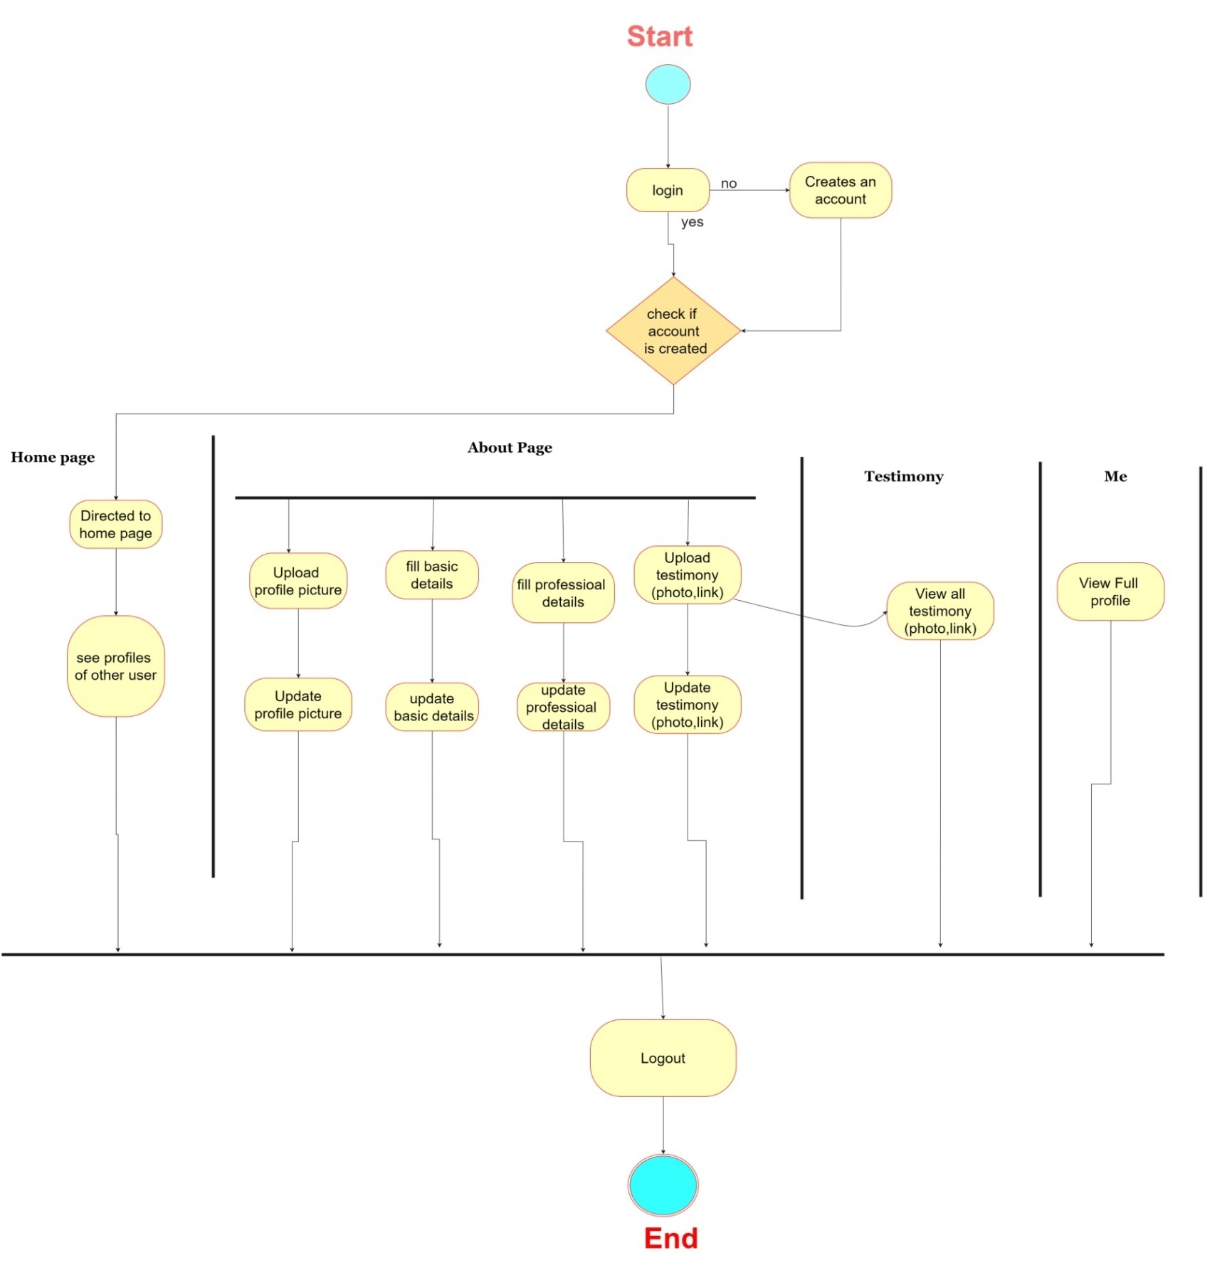

**Deployment Diagram**

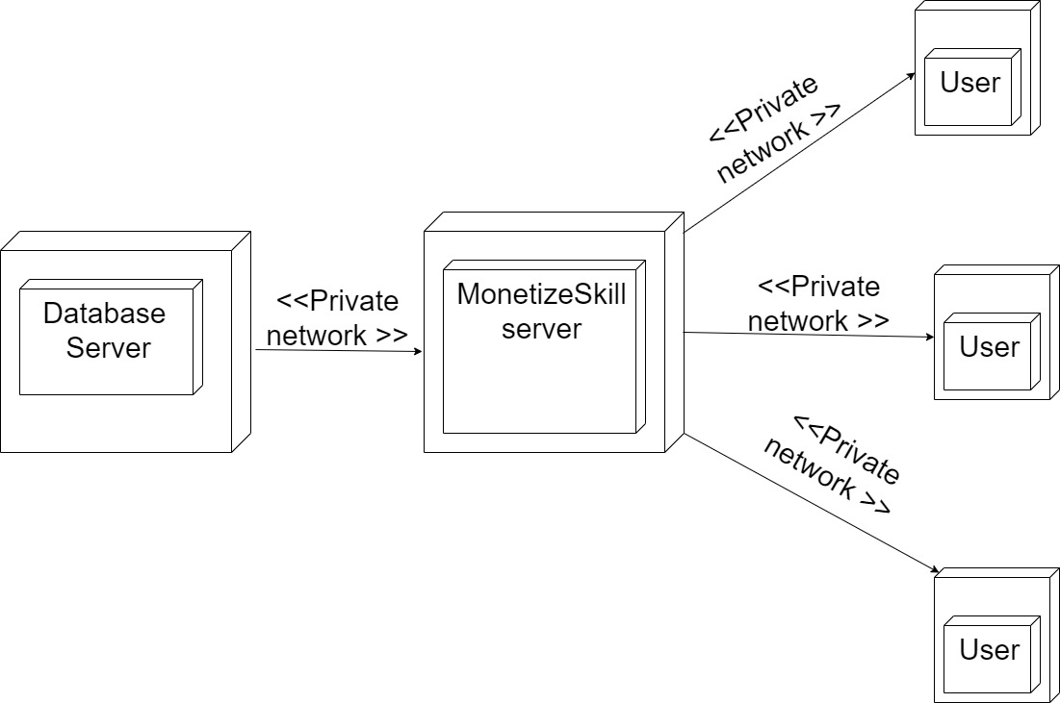

**Implementation details**

* This web site can run on a low specification PC.
* The system must contain at least
* 4 GB RAM.
* 500 GB storage capacity.

**User Interface**

Login page:

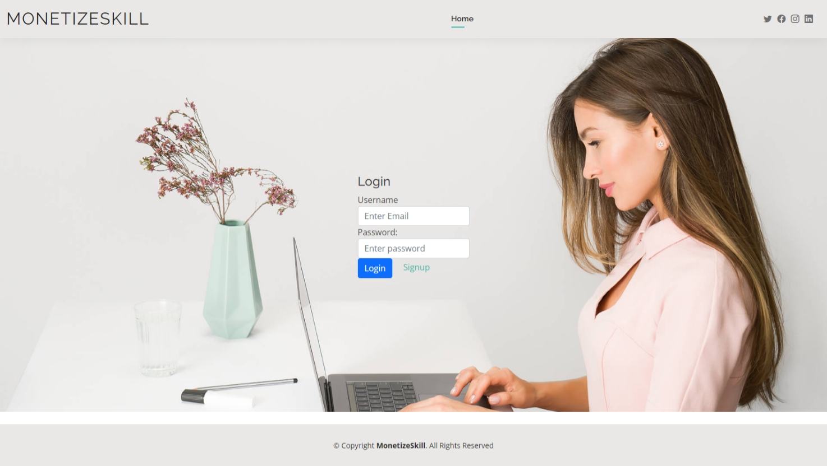

Signup page:

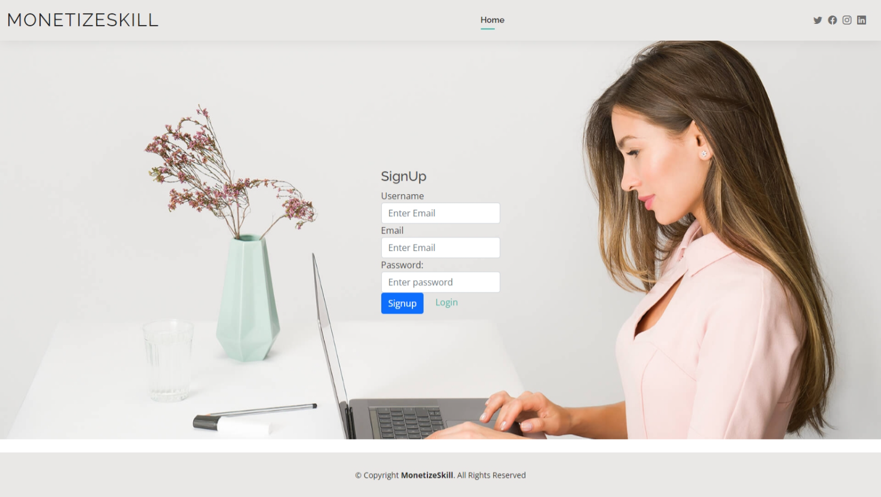

Home:

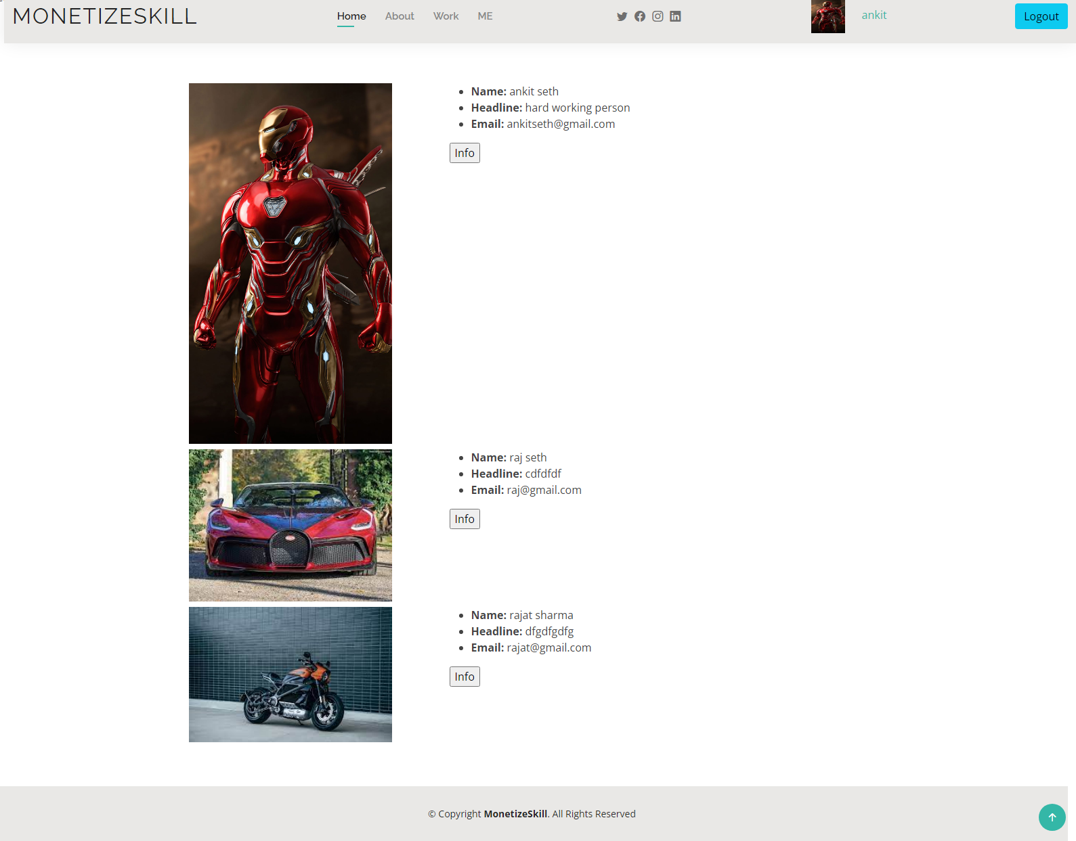

About:

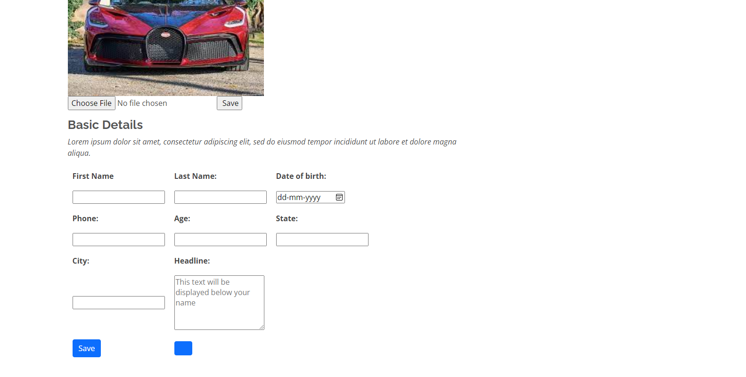

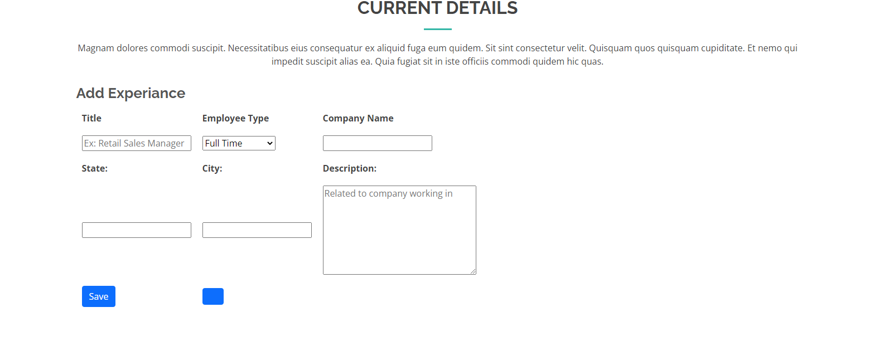

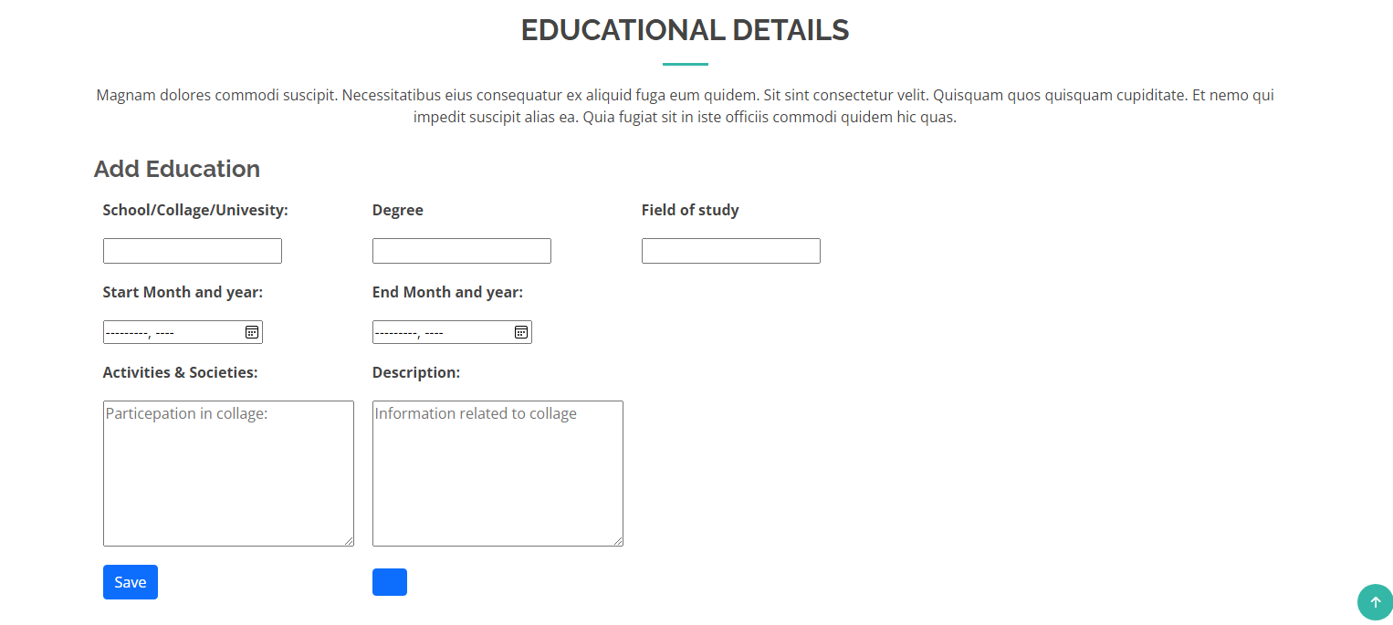

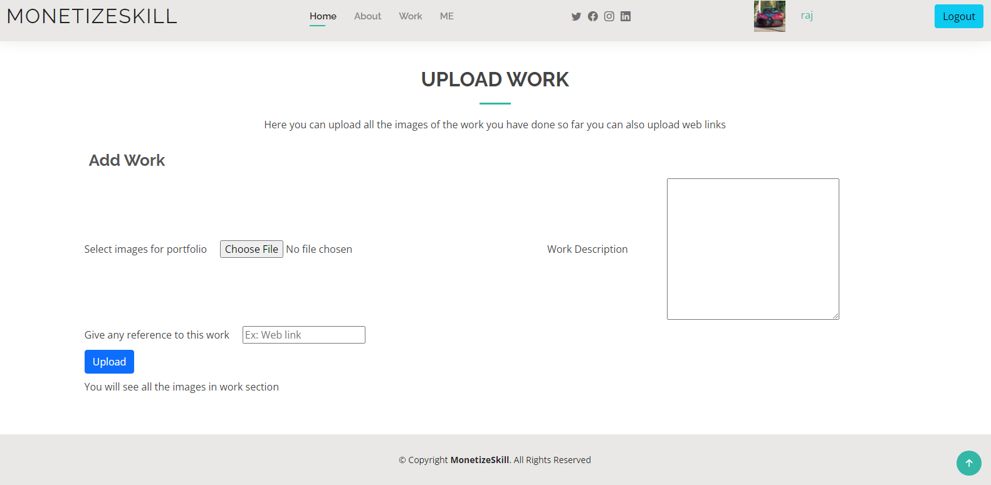

Work:

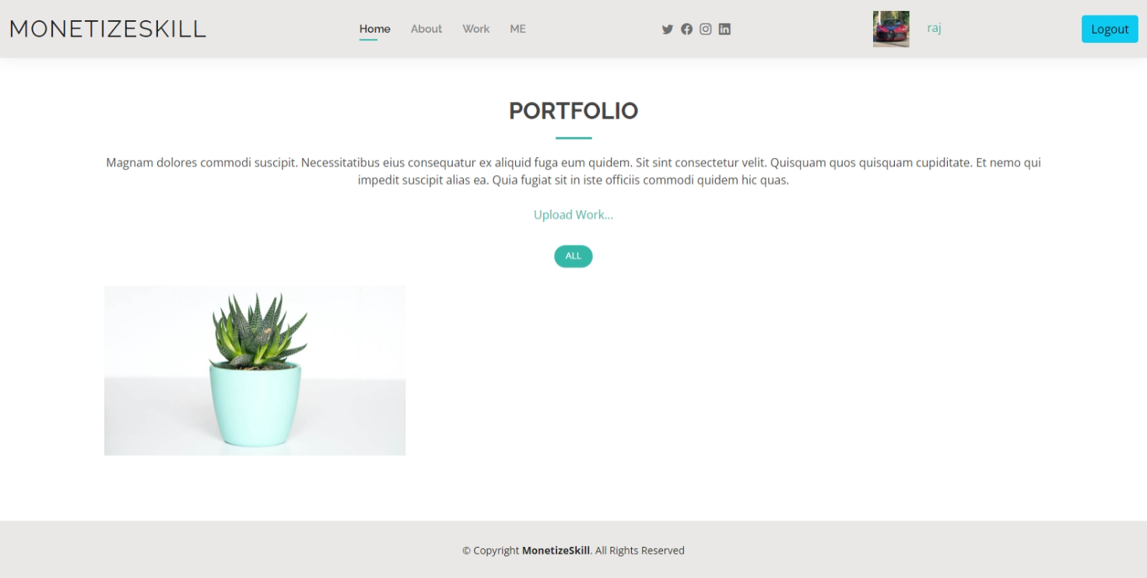

Me:

